gorsehall2**Mental Health Newsletter Autumn 2022**

**Pupil Wellbeing Survey Autumn 2022**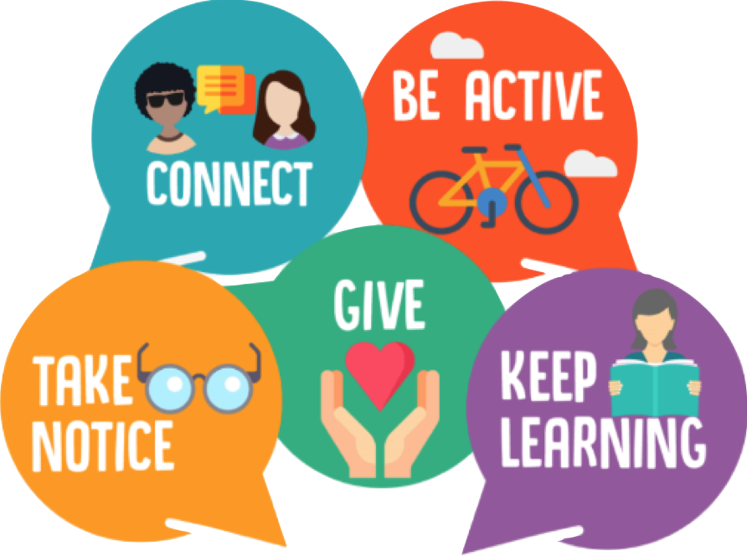

**To help us support our pupils as much as possible, please could you ask you complete this survey (if younger, an adult may need to read the questions to you). We would like you to be as honest as youcan and not answer how you think you should answer. Findings will be used for school purposes only stored securely, results shared with parents (anonymous –no names) and discarded when analysed.**

<https://forms.office.com/Pages/ResponsePage.aspx?id=DmzfroyUKU6J6y7gqcrLioXKzuTyQO5AgYvEHDFYJq5UOUNUQ0xIMDFQU0VLUzFWVEo3OTAyN1hLMi4u>



**Sleep**

**Music**

Listen to calm music before you go sleep. It can help with you calming down.

**Temperature**

Make the temperature is just right in your room . If the temperature is to hot or cold you won`t be able to go sleep.

**Light**

Make sure your room has the right amount of light . If it is too bright you won`t be able to go to sleep.

**Temperature**

Make the temperature is just right in your room. If the temperature is to hot or cold you won`t be able to go sleep. 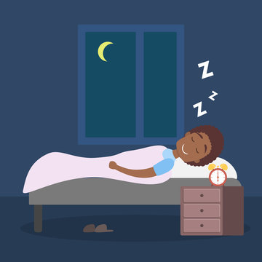

**Meet our Wellbeing Ambassadors**!

**With our new term well underway, we would like to introduce our Wellbeing Ambassadors. They are part of the Wellbeing team at Gorse Hall and give pupils a voice to help shape our mental health support at school and in the wider community.** 

**Do you need further help with your mental health /wellbeing? Are you 8 years old or older? You can drop in to Anthony Seddon on Catherine Street, Ashton on Wednesdays between 4-8pm. If you need a referral, they can put you in touch with the correct support. There are lots of activities and workshops to support you. Ask Miss Evans for more details.**

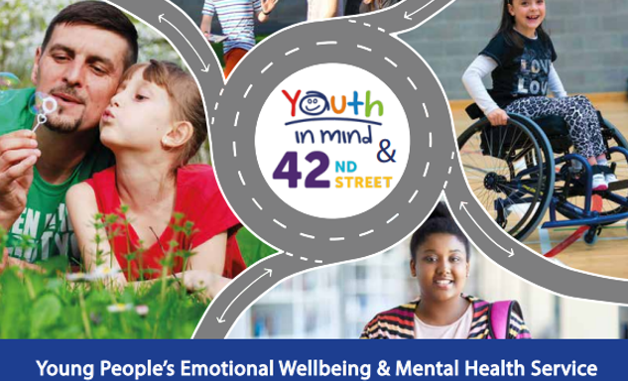

Call **0161 330 9223** (it is always best to ring first).

Email: [thehive@togmind.org](mailto:thehive@togmind.org)

**Bullying including Cyberbullying**

<https://www.childline.org.uk/info-advice/bullying-abuse-safety/types-bullying/bullying-cyberbullying/>

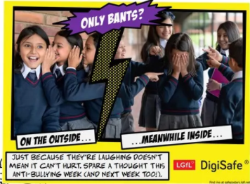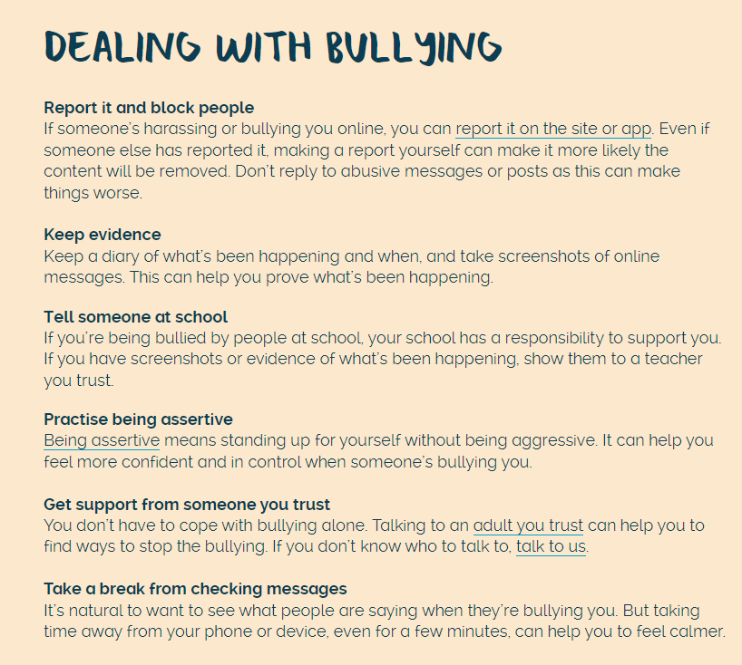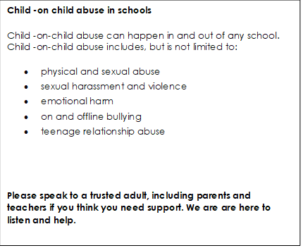

**Bereavement**

**What is bereavement?**

Bereavement simply means losing someone through death. It could be one of your parents, grandparents, brothers or sisters, friends, boyfriend or girlfriend – anyone who is important to you.

**What might I feel?**

The feelings that we have after someone close has died can be called grief. Everyone experiences grief differently – there is no ‘right’ way to feel. Feelings can include shock, numbness, despair, intense sadness, guilt, depression, relief, fear, anger. It can sometimes feel as if we’re thrown from one feeling to another to another. It’s not unusual to feel numb, which means feeling like you have no feelings at all.

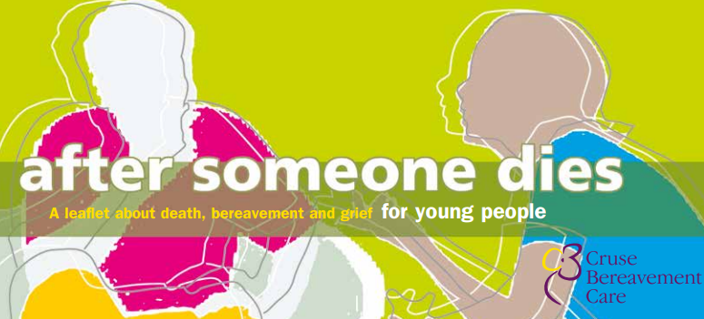

For more support and advice:

<https://www.cruse.org.uk/wp-content/uploads/2021/09/AfterSomeoneDiesforYoungPeople.pdf>

