gorsehall2gorsehall2

Year 5 UK and South America Sticky knowledge mat Summer 1

|  |
| --- |
| **Exciting websites** |
| -kids-world-travel-guide South America  -National Geographic kids  -BBC bitesize |

|  |  |
| --- | --- |
| **Subject Specific Vocabulary** | |
| **Physical characteristics** | Is a natural landmark such as a river or a mountain |
| **Human characteristics** | Is something that is man-made, for example a building or a monument |
| **Climate** | Is the usual or average weather conditions over a long period of time |
| **Vegetation** | Different types of plants in a particular place |
| **Biomes** | Are regions of the world with similar climate (weather, temperature) animals and plants. |
| **Deforestation** | Is the clearing, or cutting down, of forests |
| **Equator** | Is an imaginary circle around Earth. It divides Earth into two equal parts. |
| **Adaptation** | are special features that plants and animals develop to suit the place where they live |
| **Urban area** | Is a developed town or city, which typically has a large population. |
| **Rural area** | Is found outside of towns and cities, with smaller settlements and a lower population. |

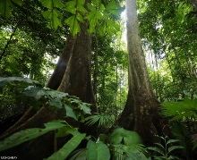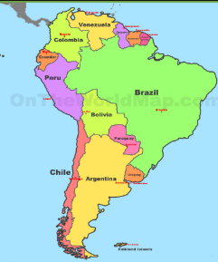

|  |
| --- |
| **Sticky Knowledge about UK and South America** |
| The UK is made up of 4 countries: England, Wales, Scotland and Northern Ireland. South America is much bigger and is made up of 13 countries. |
| The Tropical Zone – the region between the two tropics – is the hottest part of the Earth. |
| Vegetation grows in the Amazon rainforest due to the hot, humid and wet environment in the rainforest. |
| The Amazon rainforest is rapidly decreasing due to an increase in deforestation. |
| There are four different layers in the Amazon Rainforest: emergent layer, canopy layer, understory layer and the forest floor. |
| Urbanisation is when people move from rural areas such as villages to urban areas such as cities for a better quality of life. |