Summer 1 Curriculum matters

Our theme this half term in Year 5 ‘**What is a Rainforest**?’ has a Geography focus.

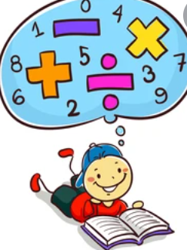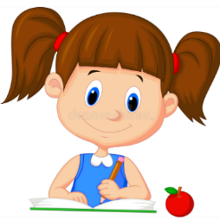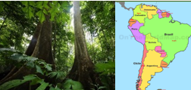We will also be studying South America and comparing it to the UK. We will be describing key physical and human characteristics of South America. We will be locating places studied in relation to the equator, Tropics of Cancer and Capricorn. We will be focusing on how climate and vegetation are connected in an example of a biome. We will also be comparing how life is different in South American cities compared to villages in South America.

|  |
| --- |
| English  This half term, we shall be writing diaries based on our text ‘How to be an explorer- An adventurer’s guide’. We will also be using our persuasive writing skills to create a holiday brochure about Brazil and will be writing a piece of descriptive writing about a tropical rainforest. Sentence level work will continue to focus on improving sentence structures and using modal verbs. Word level work will focus on definitions of words and synonyms to practise using dictionaries and thesauruses.  Reading  Children will participate in weekly whole class guided reading sessions.  Home English targets   * to use look, cover, write, and check to practise spellings * To continue making sentences as detailed as possible by adding extra clauses |
| Maths  The Mathematical areas included in the first half of the Summer Term are:   * Rounding decimals * Ordering and comparing decimals * Adding and subtracting decimals with a different number of decimal places * Decimal sequences * Multiplying and dividing decimals by 10,100 and 1000 * Identify angles * Measuring angles in degrees and with a protractor   Home maths target  Practise calculating percentages when out shopping when the sales are on.  **ONGOING SKILL- Practise telling the time using analogue and digital clocks, including using the 24 hour clock if still not confident.** |
| Art  Children will experiment with repeated patterns and colour schemes that reflect the rainforest. The children will choose a design and revisit it to work it into a pattern for printing. |
| Computing  Children will continue to carry out complex searches, to support their independent research. They will learn to cross reference information to check for reliability.  The children will also learn how to create flow charts. This unit introduces children to flowcharts and how they are used to program and control devices. |
| Religious Education  Our R.E. topic this term is Christianity. Children will learn about the beliefs of Christians and the effect of these upon their daily lives. We will also learn about the significance of signs and symbols to Christians. |
| Physical Education  As usual, this half term, we have sports coaches coming in to teach new skills leading up to small team games including rounders. |
| Music  In year 5, the children will participate in a weekly music session with music specialist Ms. Stone. |
| Jigsaw  This half term’s theme is Relationships.The children will be comparing different types of friendships. They will be learning how to stay safe when using technology, how to negotiate and how to resist peer pressure. |

[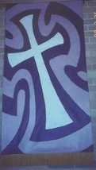](http://www.picsearch.co.uk/imageDetail.cgi?id=9W2APXs7nG1-SCTqTkHcVyJzkbu6CZD7_jBB023S1a4&start=1&q=cross%20outline)MC900437569[1]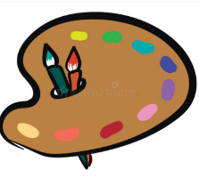

Homework

**Maths homework will be set every Friday** and is to be returned to school by the following Tuesday.

English homework, directly connected to the **Spag lesson, will be set on Tuesday**, to be returned the following Friday.

**Spellings will be sent home on Wednesday** with a spelling test each Wednesday. There will also be a weekly times table challenge every Wednesday.