**Spring 2 Curriculum matters**

Our History theme for the next half term will be:

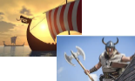‘Why were they called the Dark Ages’ and focuses on the Anglo-Saxons and Vikings

We will be studying:

* The invasions the Saxons and the retreat of the Romans from Britain-.
* Settlement of the Anglo-Saxons and the origin of place names- mapwork.
* Anglo-Saxon culture and artefacts.
* Conversion of the Anglo-Saxons to Christianity-
* Why the Vikings raided Britain and where they came from- Identifying features of Viking life.
* Significance of Anglo-Saxon kings during Viking period
* 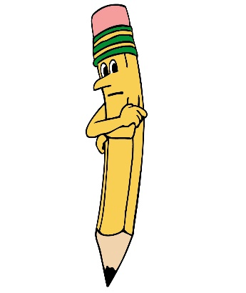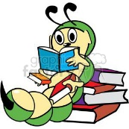Key events concerning Ethelred and Danegeld

|  |
| --- |
| English  This half term, we shall be studying letter writing- both formal and informal, report writing and Kennings (a type of poem) These will all be linked to our Anglo-Saxons and Vikings History theme.  Sentence level work will include the use of embedded clauses, extended noun phrases, adverbial clauses, relative clauses and a range of other sentence types that help to make children’s writing more interesting for the reader.  Word level work will include further developing advanced punctuation marks and prefixes and suffixes  Reading  Children will participate in weekly whole class guided reading sessions.  Home English target  To magpie interesting vocabulary from my reading to enhance my writing. |
| Maths  We shall be concentrating on the following topics this half term:  Fractions   * Number sequences * Compare and order fractions less than 1 and greater than 1 * Add and subtract fractions * Multiply fractions by whole numbers * Calculating fractions of an amount   Decimals and Percentages   * Decimals up to 2.d.p * Thousandths as decimals * Rounding decimals * Ordering and comparing decimals * Understanding percentages * Percentages as fractions and decimals and equivalent F.D.P   Home maths target   * Practise calculating percentages when out shopping when the sales are on. |
| Computing  We will use computers for research in to our Anglo-Saxon and Vikings theme and will continue to use times tables rock stars. The children will also focus on 3D modelling. In this unit the children extend their drawing skills to create 3D models based on using the software SketchUp Make. |
| Religious Education  Whist continuing to develop their understanding of the Islam faith, children’s learning will focus on:   * The origins of Islam, including their Holy book- The Qur’an * The Muslim place of worship: The Mosque and Prayer mats * The importance of the duties and rules of The Five Pillars of Islam * The Islamic celebration Ramadan |
| MC900094765[1]Physical Education  This half term, our coaches will be teaching a range of athletics skills and continue to play small team games. |
| Art  Our Art will be linked to our History theme and will include designing Anglo-Saxon brooches, carvings and illuminated letters. We will also be sculpting Viking objects. |
| Music  In year 5, the children will participate in a weekly music session with music specialist Ms. Stone. |
| Geography  We will be completing a short Geography unit focusing on the UK- its countries and capital cities. We will be examining different types of settlements (especially those with Anglo-Saxon place names) and looking at the European countries that the invaders came from. |
| PSHE-Jigsaw  Our theme for this half term will be ‘Healthy me’ and is focusing on having a healthy life style and avoiding risky behaviours. |

  
Homework

**Maths homework will be set every Friday** and is to be returned to school by the following Tuesday.

English homework, directly connected to the **Spag lesson, will be set on Tuesday**, to be returned the following Friday.

**Spellings will be sent home on Wednesday** with a spelling test each Wednesday. There will also be a weekly times table challenge every Wednesday.