Year 6 Spring 2
Curriculum Matters

Our theme this half term in Year 6 is ‘What Made Manchester Great?’ which is primarily history and geography based. Children’s studies will include:
- Physical and human geography of Manchester
- The birth of the industrial revolution
- The cotton industry
- Movement from the countryside to the city

This half term our Literacy topics link closely to our What Made Manchester Great? Theme and to the Industrial Revolution.
This will involve exploring, practising and developing the features of a range of text types, including diaries, poems and newspaper reports.

We will continue to include a range of Year 6 grammatical features, especially:
Parenthesis using brackets, commas and dashes
Colons and semi colons to separate main clauses
Multi-clause sentences

Target: To identify and use the key features required for a range of
different genres.
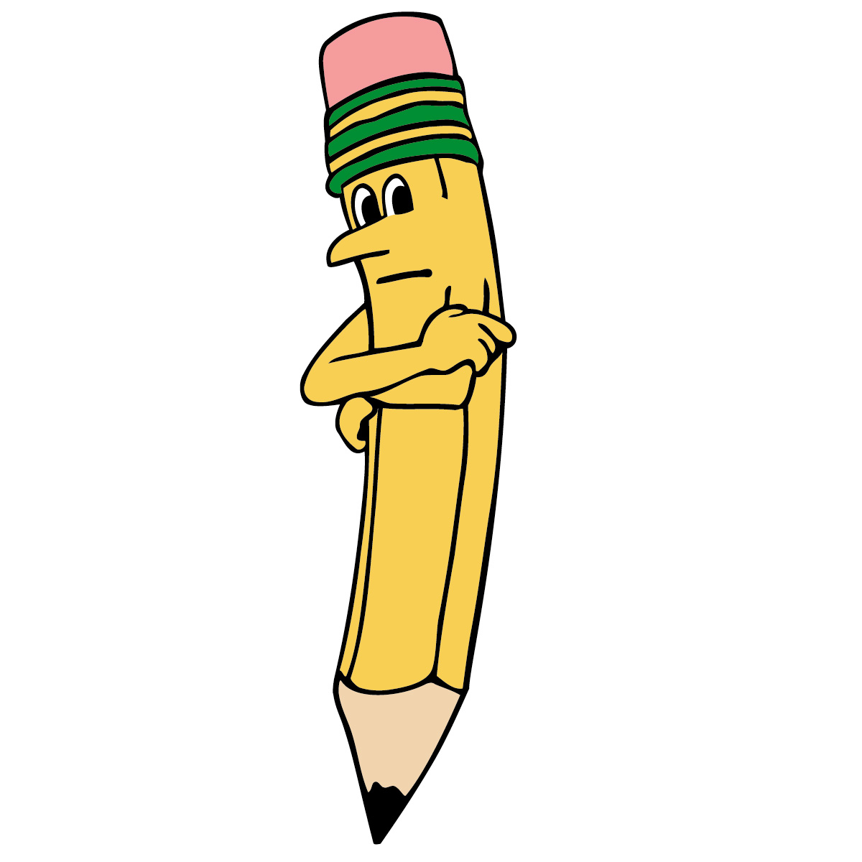


We will all be revising a number of mathematical areas and concepts in preparation for the SATs, such as arithmetic, written methods and problem solving.

Most groups will also be covering the following:
- Ratio and proportion
- Area, Perimeter and volume
- Properties of 2d and 3d shapes
- Converting units of measure

Target: To develop our problem-solving techniques and explain our methods



R.E.
In RE this term, we will be looking at the significance of places of worship for different world religions including Christianity, Islam, Judaism, Hinduism and Sikhism.

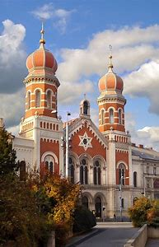

PSHE
In our ‘Jigsaw’ RE topic this term we will be exploring the theme of taking responsibility for our health and looking after our physical and emotional wellbeing.




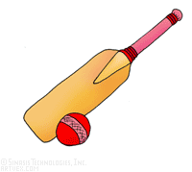
French
So far we have covered greetings, numbers and birthdays, and expect to further enhance our French knowledge this half term.
Music
The focus will continue to be exploring rhythmic patterns:
Explore the structure, lyrics, rhythm and melodies of songs.
Use percussion instruments to produce a wide variety of sounds.

PE

Tameside Sports Coaches will continue to deliver weekly PE lessons on FRIDAY afternoons. Please ensure children come to school in the correct PE kit (white, plain t shirt and black plain shorts or joggers, plain black trainers).

