[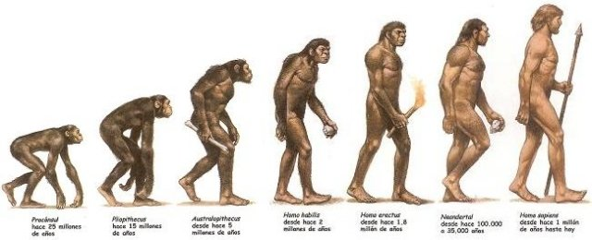](https://steemit.com/science/@geoestacion/origin-and-evolution-of-man)gorsehall2

Year 6 Sticky Knowledge Mat: Living Things, Evolution and Inheritance

|  |  |
| --- | --- |
| **Subject Specific Vocabulary** | |
| **adaptation** | When living things change over time to suit their environment. |
| **classify** | To group living things based on their similarities/differences. |
| **evolution** | The development of animals and plants from simpler forms over time. |
| **fossil** | The remains of a prehistoric animal or plant. |
| **habitat** | Where an animal or plant lives naturally. |
| **inheritance** | To get certain characteristics from our parents. |
| **invertebrate** | Animal without a backbone. |
| **microorganism** | A tiny organism such as bacteria. Needs a microscope to see it. |
| **variation** | The differences between individuals in a species. |
| **vertebrate** | Animal with a backbone. |

|  |
| --- |
| **Exciting resources** |
| Fossils! |

|  |
| --- |
| **Sticky Knowledge** |
| Living things (including animals, plants and microorganisms) are classified into broad groups according to their characteristics (e.g. reptiles are cold-blooded). |
| Classification groups include vertebrates (fish, amphibians, reptiles, birds and mammals) and invertebrates (insects, spiders, molluscs, annelids). |
| Living things produce offspring of the same kind but they are not identical. Variation in offspring over time can make animals and plants more or less able to survive in particular environments. |
| Animals and plants are adapted to suit their environment in different ways and that adaptation may lead to evolution. |
| Fossils are the remains of living things which are found in layers of rock. They tell us about living things that inhabited the earth millions of years ago and help us to understand the process of evolution. |
| Charles Darwin’s theory of evolution explains how every living thing is connected in a family tree that stretches back billions of years to the beginning of life on Earth. |