**Spring 1 Curriculum matters**

One of our themes this half term is Science based - **‘Can you feel the force?**’ We will be studying:

* The force of gravity acting between Earth and falling objects
* The effects of air resistance, water resistance and friction
* 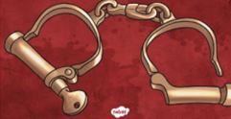How mechanisms affect forces

Wherever possible, children will learn from direct experience and complete hands-on investigations.

Our other theme is the History based ‘**How crime and punishment has changed over time?’** We will be studying:

* 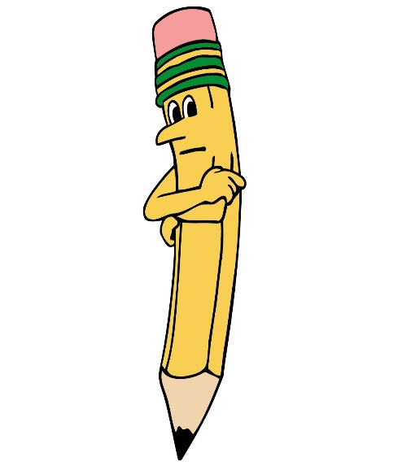Chronological knowledge of how crime and punishment has changed in Britain from Anglo-Saxons to modern day

|  |
| --- |
| English  This half term, we shall be studying   * Narrative poetry based on ‘The Highwayman’. * Narrative from a different viewpoint linked to ‘The Highwayman’– using features of the text type. * Highwayman biography.   Sentence level work will include the development of a range of more complex sentence types that help to make children’s writing more interesting for the reader. Word level work will include further developing advanced punctuation marks, including commas, brackets, colons and in-speech punctuation, figurative language and the different uses of the apostrophe.  Reading  Children will participate in weekly whole class guided reading sessions.  Home English target  To use a wider range of sentence types independently, following on from work in class (applying Spag skills) |
| http://www.esmschools.org/Data/FileManager/Pine%20Grove%20MS/Duffy/Pictures/math_clipart.jpgMaths  As outlined in the National Curriculum, our units of work include:  Multiplication and division:   * Multiply 1-digit by up to 4-digits * Multiply 2-digits by up to 3-digits * Divide up to 4-digits by 1-digit   Fractions:   * Equivalent fractions * Improper fractions to mixed numbers * Mixed numbers to improper fractions   Home maths target:  Practise multiplying and dividing numbers together using formal methods. |
| Music  In year 5, the children will participate in a weekly music session with music specialist Ms. Stone. |
| Computing  We will be creating our own story sequences linked to our study of ‘The Highwayman’. We will also be conducting research on the history of highwaymen. The children will also be learning about what makes a good webpage and they will design their own web page. |
| R.E. – Judaism  Whilst developing their understanding of the Jewish faith, children’s learning will focus on:   * The origins of Judaism, including the Torah * The importance of rules and promises by considering the Ten Commandments * The Jewish celebrations of Shabbat and Bar Mitzvah |
| Design and Technology  We are investigating commercial toys and cam mechanisms. The children will then design, make and evaluate their own moving toy. |
| PSHE Jigsaw- Dreams and Goals  The PSHE lessons will focus on:   * Understanding different jobs and what motivates them * Describing the dreams and goals of a person who is from a culture different to mine * Understanding that communicating with someone in a different culture helps can learn children to learn from each other |
| PE  This half term children will continue to work with our Sports Coaches, developing ideas for small games such as basketball. |

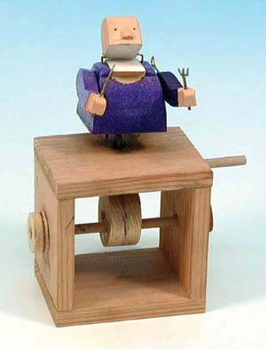j0239405

Homework

**Maths homework will be set every Friday** and is to be returned to school by the following Tuesday.

English homework, directly connected to the **Spag lesson, will be set on Tuesday**, to be returned the following Friday.

**Spellings will be sent home on Wednesday** with a spelling test each Wednesday. There will also be a weekly times table challenge every Wednesday.