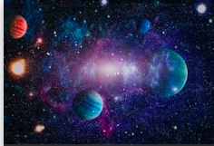**Autumn 1 Curriculum Matters**

Our theme this half term is ‘What’s in Our Galaxy? which is primarily science based. It focuses on ‘Earth and Space’, Children’s studies will include:

* 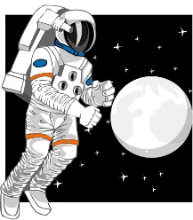The relative sizes of the Earth, Sun and Moon
* Early theories about the Universe
* Sun and Shadows
* Planets and Moon
* How we get day and night

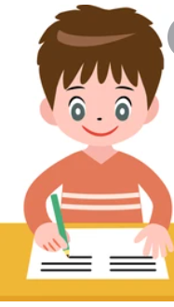j0217698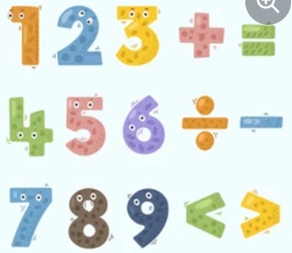Wherever possible, children will learn from direct experience.

|  |
| --- |
| English  We will be looking at different forms of poetry and non-chronological reports and descriptive writing based on our Space topic.  We will be concentrating on the following objectives this half term:   * Preparing poems to read aloud and perform. * Use organisational features to structure a non-fiction text, compare, and contrast non-chronological reports.   Reading  Children will participate in weekly whole class guided reading sessions.  Home English Target:  Read information about Space topic and share any written research with the class.  Read regularly (at least three times a week either alone or with an adult) |
| Maths  We will be focusing on place value, addition and mental calculations.  We will be concentrating on the following objectives this half term:  Place Value   * Read, write, order and compare numbers to at least 1,000,000 and determine the value of each digit. * Rounding numbers to 1 million * Negative numbers * Roman numerals   Addition and Subtraction   * Adding two 4-digit numbers with more than one exchange * Subtracting two 4-digit numbers with more than one exchange * Round to estimate and approximate * Inverse operations   Home Maths target:  Regularly practise multiplication tables (in and out of order). When you know these thoroughly, practise the related division facts. |
| Art  We will study ‘The Starry Night’ by Van Gogh. Children will consider his themes and create our own work in the style of the artist. |
| P.E.  Each half term children will be learning skills with the sports coaches.  P.E. will be on Thursdays for both Year 5 classes and they will be focusing on hockey. |
| Religious Education  Our R.E. topic this term is Christianity. Children will learn about the beliefs of Christians and the effect of these upon their daily lives. We will also learn about the significance of signs and symbols. |
| Computing  The children will be using a blogging programme to report and share ideas on the topics covered in school as well as focusing on e-safety. |
| Music  In year 5, the children will participate in a weekly music session with music specialist Ms. Stone. |
| Jigsaw PSHE  The topic this half term is ‘Being me in my world’. The children will identify children who live differently to them and explain the positive impacts of being part of a community. The children will also focus on why we have right, rules and responsibilities. |

j0205582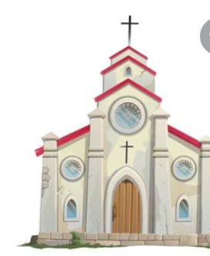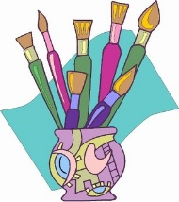

Homework

**Maths homework will be set every Friday** and is to be returned to school by the following Tuesday.

English homework, directly connected to the **Spag lesson, will be set on Tuesday**, to be returned the following Friday.

**Spellings will be sent home on Wednesday** with a spelling test each Wednesday. There will also be a weekly times table challenge every Wednesday.