gorsehall2gorsehall2

|  |
| --- |
| **Exciting Books**  What is it made of? Year 2 Science Knowledge Mat |
| [Fundamental Science Key Stage 1: Everyday Materials 2016 by Ruth Owen](https://wordery.com/fundamental-science-key-stage-1-everyday-materials-2016-ruth-owen-9781910549858?currency=GBP&gtrck=dWc2MEttM0o4ZGd3Skp5RzRSRFgxbllGSXBEeTl6MHJSeHd5TjFiT0FlelhjS3piOXlEZnpLdlZWdUluR3dCT2t2MjVCSkM0TGthdWZ2cnRmenBFM1E9PQ&gclid=EAIaIQobChMIkcSF_uyv5QIVVODtCh0ckgAUEAQYAyABEgLMIPD_BwE#gallery) |

|  |  |
| --- | --- |
| **Subject Specific Vocabulary** | |
| **materials** | Is what something is made of, e.g. wood or plastic. |
| **wood** | The material that comes from a tree. |
| **plastic** | A ‘man-made’ material that can be moulded to any shape. |
| **metal** | A tough and strong material that can be heated and shaped. |
| **liquid** | Liquids can flow and take on the shape of their container. |
| **stretch** | A stretchy material is one that is like elastic. |
| **stiff** | A stiff material is firm and hard and not flexible. |
| **flexible** | Something that can bend easily. |
| **waterproof** | Is a material that does not allow water or liquid to go through. |
| **bend** | A bendy material is one that can be twisted and is flexible. |

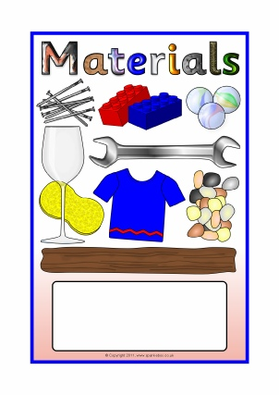

|  |
| --- |
| **Sticky Knowledge about materials** |
| **Leather** – used for shoes, jackets and trousers- comes from animals |
| **Wool** – used for jumpers, socks, pyjamas and coats comes from sheep |
| **Cotton** – used for clothes we wear on warmer days and shirts – comes from a cotton plant |
| **Silk** – expensive materials used for scarves, blouses |
| **Rock** -a hard substance made of minerals, often found in or on the ground |

|  |
| --- |
| **Important Bits** |
| * Identify and compare the suitability of a variety of everyday materials including wood, metal, plastic, glass, brick, rock, paper and cardboard for particular uses * Set up an experiment to find out how shapes of solid objects are made from some materials that can be changed by squashing, bending, twisting and stretching |