gorsehall2gorsehall2

Where does it live? Year 2 Science Knowledge Mat

|  |
| --- |
| **Exciting Books** |
| Image result for wild emily hughes |

|  |  |
| --- | --- |
| **Subject Specific Vocabulary** | |
| **rivers** | A river is a flowing, moving stream of water. Usually a river feeds water into an ocean, lake, pond, or even another river. |
| **woodland** | Woodland is a forest with plenty of sunlight and limited shade. |
| **ponds** | A pond is a body of water smaller than a lake. Ponds support a very wide range of wildlife. |
| **sea** | A sea is part of the ocean partially enclosed by land. |
| **rainforest** | Tropical rainforests are forests with tall trees, warm climates, and lots of rain. |
| **desert** | A desert is any large region that gets very little rain each year. Very few plants or animals live in desert areas. |
| **species** | A group of animals, plants or other living things that all share common characteristics and that are all classified as alike in some manner. |
| **microhabitats** | Microhabitats are small areas that differs from surrounding  habitat. The conditions may be home to different species. |

|  |
| --- |
| **Important facts to know by the end of the habitats topic:** |
| * Identify things that are living, dead and never been alive * know how a specific habitat provides for the basic needs of things living there * identify and name plants and animals in a range of habitats * match living things to their habitat including microhabitats * know how animals find their food * name some different sources of food for animals |

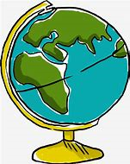

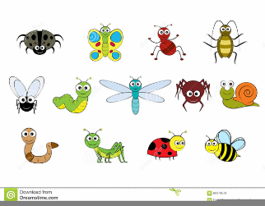

|  |
| --- |
| **Sticky Knowledge about different habitats in the world** |
| A habitat is a place that an animal lives. It provides the animal with food, water and shelter. |
| There are many different sorts of habitats around the world from forests to grasslands and from mountain slopes to deserts. |
| Animals like cockroaches are really important in a habitat -they eat the dead plants and recycle the nutrients back into the soil. |
| Because resources like water and food may be limited, plant and animal species often compete with each other for food and water. |
| Because the Earth is always changing, habitats are constantly changing. |

gorsehall2gorsehall2

Where does it live? Year 2 Geography Knowledge Mat

|  |
| --- |
| **Exciting Books** |
|  |

|  |  |
| --- | --- |
| **Subject Specific Vocabulary** | |
| **North Pole** | The North Pole is the northernmost place on Earth. When at the North Pole all directions point south. |
| **South Pole** | The South Pole is the southernmost place on Earth. When at the South Pole all directions point north. |
| **Equator** | Is an imaginary line around the centre of the Earth. It is very hot at the Equator. It divides the Earth into the north and south hemispheres. |
| **Meerkats** | Animals that are often found in dry places like deserts. They belong to the mongoose family. |
| **desert** | A desert is a place where almost no rain falls. Very few plants of animals live there. |
| **humid** | When there is a lot of moisture in the air it is said to be humid. Hot countries often are very humid. |
| **camouflage** | When an animal’s markings helps it to blend in with its environment. |

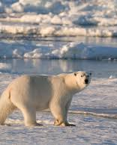 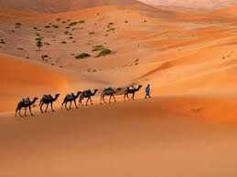

|  |
| --- |
| **Sticky Knowledge about different habitats in the world** |
| Hot deserts are very hot during the day but can get very cold at night. |
| Some hot deserts can reach freezing point at night. |
| The largest hot desert in the world is the Sahara |
| The largest cold desert is Antarctica |
| Even though we think they should be, not all deserts are hot. Two of the world’s biggest deserts are in the North and South Poles. |
| Polar bears and penguins are able to keep warm because they have blubber inside their skins |
| Polar bears live in the North pole, Penguins live in the South pole |
| During the South Pole winter (mid March to mid September) it is dark all the time. During the summer it is light all the time. |

|  |
| --- |
| **Important Bits** |
| **Animals that live in the polar regions**   * penguins * polar bears * arctic fox * seal * reindeer * walrus   **Animals that live close to the equator**   * meerkats * lizards * scorpion * coyote * camel |