Gorse Hall Primary and Nursery School

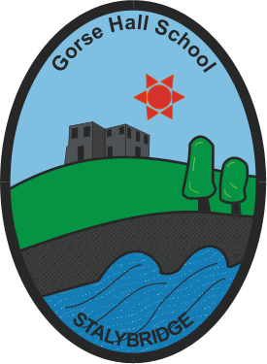

Pupil Wellbeing and Mental Health Policy

Devised: February 2021
Review date: February 2022
At Gorse Hall Primary and Nursery School, we are committed to supporting the mental health and wellbeing of all our pupils. Our culture is supportive, caring, and respectful. We encourage pupils to be open and we want each pupil to have their voice heard. At our school, we know that everyone experiences different life challenges, and that each of us may need help to cope with them sometimes. We understand that anyone and everyone may need additional emotional support. At our school, positive mental health is everybody’s responsibility. We all have a role to play.
POLICY SCOPE
This policy is a guide to all staff, including teachers, governors, and non-teaching staff. It outlines our approach to promoting pupil mental health and wellbeing. It should be read and understood alongside our other relevant school policies:
Child Protection and Safeguarding Policy
Anti-bullying Policy
Behaviour Policy
Staff Wellbeing Policy
National Guidance:
Transforming Children and Young People’s Mental Health Provision: A Green Paper (2018)
Statutory:
Keeping Children Safe in Education (2020)
POLICY AIMS
The aim of our policy is to demonstrate our commitment to the mental health of our pupils.
At Gorse Hall, we will always:
- Help children to understand and regulate their emotions.
- Ensure our pupils feel comfortable sharing any concerns and worries.
- Help children to form and maintain relationships.
- Encourage children to be confident and help to promote their self-esteem.
- Help children to develop resilience and ways of coping with setbacks.
- Develop a good mind-set.
We will always promote a healthy environment by:
- Promoting positive mental health and emotional wellbeing.
- Celebrating both academic and non-academic achievements.
- Promoting our school values and encouraging a sense of belonging and community.
- Providing opportunities to develop a sense of worth and to reflect.
- Promoting our pupils’ voices and giving them the opportunity to participate in decision making.
- Celebrating each pupil for who they are and making every pupil feel valued and respected.
- Adopting a whole school approach to mental health and providing support where needed it.
- Raising awareness amongst staff, parents and pupils about mental health issues and their signs and symptoms.
- Enabling staff to respond to early warning signs of mental-ill health in pupils.
- Signposting pupils and their families to internal and external support.

KEY STAFF MEMBERS
All staff members have a responsibility to promote the mental health of pupils and each other. However, certain staff members have a specific role in the process.
These are:
- Our Designated Safeguarding Officers: Alexandra Flood/Jane Evans/Nazia Suleman
- Wellbeing Team: Jane Evans(Lead and Mental Health Champion)/Nazia Suleman SENCO)/Janine Hand (Mental Health Champion)/Sam Abbott/Nicola Thompstone
- Welfare and Learning Officer: Jane Troy
- Mental Health Link Governor: Glynn Goodchild
If a member of staff is concerned about the mental health and wellbeing of a pupil, then in the first instance they should speak to: Alexandra Flood/Jane Evans/Nazia Suleman. If a child presents a medical emergency then relevant procedures will be followed, including involving the emergency services.
TEACHING ABOUT MENTAL HEALTH
Our PHSCE curriculum is developed to give students the skills, knowledge, and understanding they need to keep themselves mentally healthy. This includes resilience and breathing techniques, mindfulness and self-confidence as well as exploring ways in which they can keep themselves safe and healthy. Our PHSCE curriculum is taught on a weekly basis through our whole school Jigsaw scheme of work. We will regularly review our PHSCE curriculum and lesson content to ensure that they’re meeting the aims outlined in this policy. We’ll also implement this into our curriculum at all stages throughout the year to provide students with strategies to help keep them mentally well.
SUPPORT AT SCHOOL AND IN THE LOCAL COMMUNITY
Gorse Hall is part of a local cluster of Mental Health support and is part of the Nationwide and local ‘Link Programme network’. Development of a ‘Schools Mental Health Network’ in each neighbourhood is underway and will develop, sustain and grow these partnerships, facilitated by a programme officer. We have a range of support available in school for any pupils struggling, as listed below:
- Circle time incorporated into weekly PHSCE lessons
- Weekly Mindfulness sessions
- Counselling Support staff
- Programs for individual support- Starving the Anxiety Gremlin/The Hidden Chimp where additional, internal support with anxiety
- Lego Therapy in small groups
- Nurture Groups
- Wellbeing Ambassadors/peer support
- Worry Monster resources and class worry boxes
- Regulating emotions prompt resources in each classroom
There is also a lot of support networks available for children in the local community. (See Appendix ii).
We will ensure that all staff, students, and parents are aware of the support that’s available in our school for mental health. This includes how to access further support, both inside and outside of school hours. Gorse Hall has a children’s Mental Health information board that is accessible for all pupils within the main corridor. The website also has a Mental Health and wellbeing section.
IDENTIFYING NEEDS AND WARNING SIGNS
All of our staff will be trained in how to recognise warning signs of common mental health problems. This means that they will be able to offer help and support to students who need it, when they need it. These warning signs will always be taken seriously and staff who notice any of these signs will communicate their concerns with the Designated Safeguarding Officer as appropriate.
Staff will be able to identify a range of behaviour and physical changes, including:
• Physical signs of harm.
• Changes in eating and sleeping habits.
• Increased isolation from friends and family and becoming socially withdrawn.
• Changes in mood.
• Talking and/or joking about self-harm and/or suicide.
• Drug and alcohol abuse.
• Feelings of failure, uselessness, and loss of hope.
• Secretive behaviour.
• Clothing unsuitable for the time of year, e.g. a large winter coat in summer.
• Negative behaviour patterns, e.g. disruption.
Staff will also be able to identify a range of issues, including:
• Attendance and absenteeism.
• Punctuality and lateness.
• Changes in educational attainment and attitude towards education.
• Family and relationship problems.
Finally, staff will be well placed to identify any additional needs arising from difficulties that may impact a child’s mental health and wellbeing, such as bereavement, health difficulties, and family circumstances.
MANAGING DISCLOSURES
If a pupil discloses concerns about themselves or a friend, to any member of staff, then all staff will respond in a calm, supportive, and non-judgemental manner. Staff will not ask leading questionings but repeat the pupil’s words for clarification.
All disclosures will be recorded confidentially on our electronic system (My Concern software) and will only be shared with the appropriate authorities if it’s necessary to keep the child safe, in line with our Safeguarding Policy. The disclosure record will contain:
• The date of the disclosure.
• The name of the staff member to whom the disclosure was made.
• The nature of the disclosure and the main points from the conversation.
• Agreed action.
CONFIDENTIALITY
If a member of staff thinks it’s necessary to pass on concerns about a pupil, either to a DSL inside the school or somebody outside it, then this will first be discussed with the student.
They will be told:
• Who the staff member is going to tell.
• What the staff member is going to disclose.
• Why it is necessary for somebody else to be told.
• When the contact will be.
However, it may not be possible to gain the pupil’s consent first, such as in the case of pupils who are at immediate risk. Protecting a student’s safety is our main priority so we would share disclosures if we judged a child to be at risk.
WHOLE SCHOOL APPROACH
We take a whole school approach towards the mental health of our students. This means working with parents and carers and with other agencies and partners, where necessary.
WORKING WITH PARENTS AND CARERS
We aim to support parents as much as possible. This means keeping them informed about their child and offering our support at all times. To support parents we will:
- Listen to their concerns regarding their child
- Highlight sources of information and support about mental health and emotional wellbeing that we have in our school.
- Share and allow parents to access further support.
- Ensure that parents are aware of who to talk to if they have any concerns about their child.
- Give parents guidance about how they can support their child’s/children’s positive mental health.
- Ensure this policy is easily accessible to parents.
- Keep parents informed about the mental health training our school staff receive and how mental health is covered in our school curriculum.
- Make an external referral if needed to meet the needs of the child.

WORKING WITH OTHER AGENCIES AND PARTNERS
As part of our whole school approach, we will also work with other agencies to support our pupils’ emotional health and wellbeing. Appendix i outlines advice for professionals in Tameside and Glossop.
We are part of a Link Programme whose aims are:
- To develop a shared view of strengths and limitations and capabilities and capacities of education and mental health colleagues.
- To increase knowledge of resources to support mental health of children and young people.
- To make more effective use of existing resources.
- To improve joint working between education and mental health colleagues.
This might include liaising with:
- Mental Health Support Teams (MHST)
- The school nurse
- Paediatricians
- CAMHS
- Counselling services
- Therapist
- Family support workers
- Behavioural support workers.
A full list of local services can be viewed in Appendix ii
- The Hive (TOG Mind) , Ashton -Wednesday 4-8 pm
- Off the Record , Hyde - Wednesdays 3.-6 pm
- Counselling Drop in , Hattersley, Tuesdays 3-6pm
- The Talk Shop, Anthony Seddon , Ashton
- TOG Mind
- 42nd Street
- Kooth
- Healthy Young Minds Link Workers
- Crisis care pathway

MAKING REFERRALS
Referrals for pupils can develop from a range of sources –teachers, SENCO, parents, pupils, GPs.
Single Point Access
The new multi-agency referral pathway in Tameside has been designed as a central referral point for all services that support families, including children’s mental health referrals across Tameside & Glossop.
This will ensure:
- Access to good quality information from a variety of agencies.
- There is joined up working and information sharing.
- That the child receives the most appropriate support.
- That needs are best met at the point of referral.
- Families will experience one referral with a support plan being put in place following this referral.
The referral process is outlined in Appendix iii.
SUPPORTING PEERS
We understand that, when a pupil is suffering from mental health issues, it can be a difficult time for their peers. In response to this, we will consider, on a case by case basis, any peers that may need additional support. We will provide support in a one-on-one or group setting. These sessions will be guided by the student, but they will discuss how peers can help, how peers can access support themselves, and healthy ways of coping with any emotions they might be feeling. Each Key Stage 2 classroom has an appointed Wellbeing Ambassador who lead assemblies and provide additional support and resources for pupils. Pupils can regularly share worries and concerns through PSHE sessions and classroom worry boxes.
TRAINING
All staff will receive regular training in child mental health so that they can recognise and respond to mental health issues. This will form part of their regular safeguarding training and is a requirement to keep children safe. Training records will be held in a CPD file in the office. We will post all relevant information, and additional information, on our school website so staff can learn more about child mental health. We will consider additional training opportunities for staff and we will support additional CPD throughout the year where it becomes appropriate due to developing situations with pupils.
POLICY REVIEW
This policy will be reviewed every year. This is so that it remains up to date, useful, and relevant. We will also regularly review it in accordance with local and national policy changes.

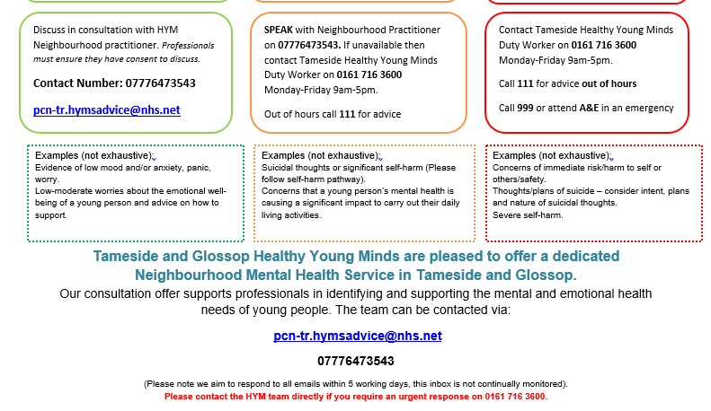
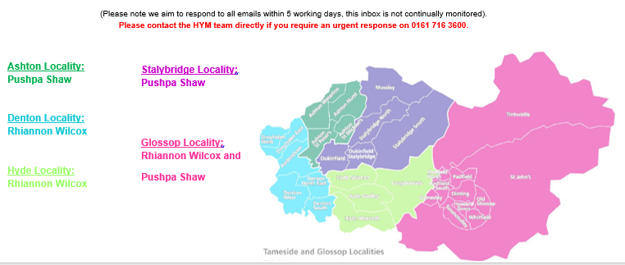
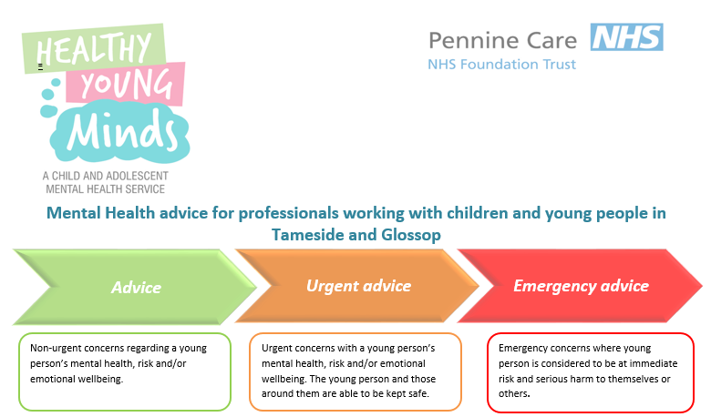
Appendix i) Mental Health Advice for professionals

Appendix ii) Local Services
Stalybridge Locality:
Pushpa Shaw
Glossop Locality:
Rhiannon Wilcox and
Pushpa Shaw

Off the Record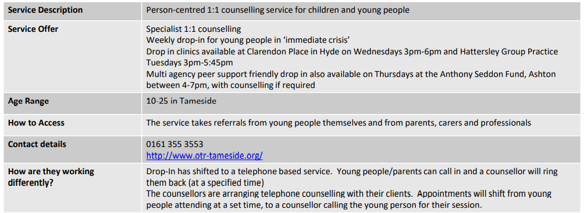

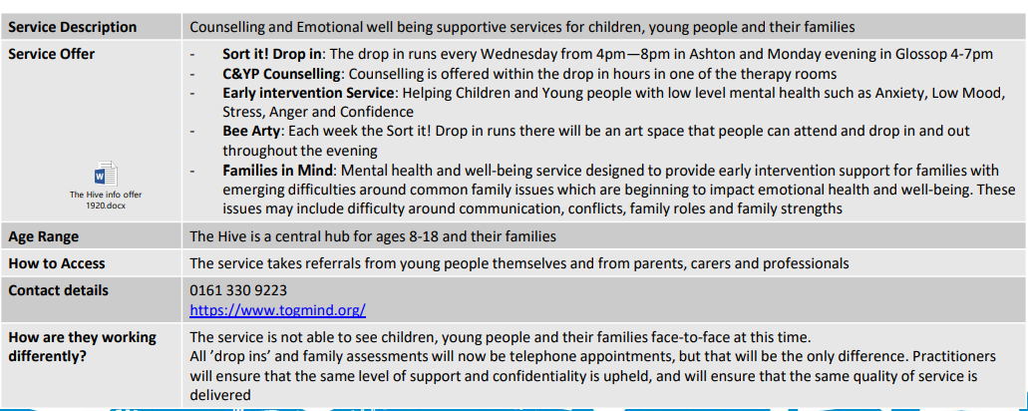
TOG

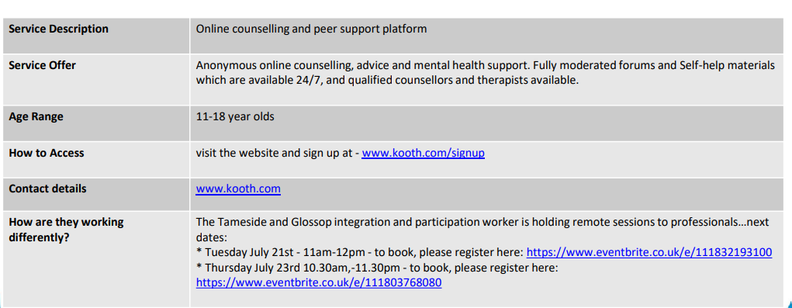
Kooth
Healthy Young Minds
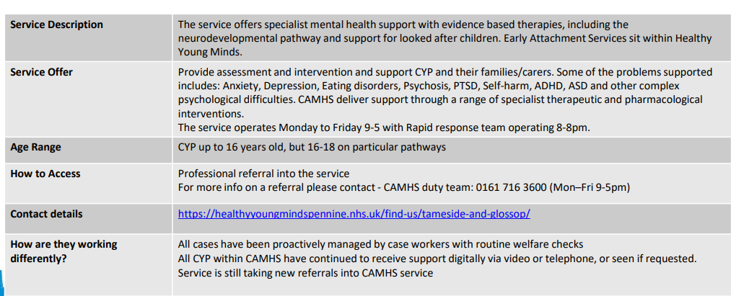

Crisis Care Pathway
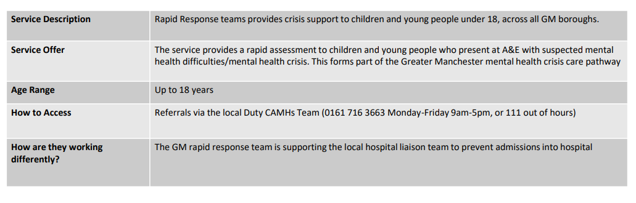

Appendix iii) Referral Process
Tameside & Glossop CAMHS Early Help Access Point: A new Child and Adolescent Mental Health referral pathway using the Multi-Agency Request for Service (MARS) pathway form.

The new multi-agency referral pathway has been designed as a central referral point for all services that support families, including, children’s mental health referrals across Tameside & Glossop. We will have access to good quality information from a variety of agencies which will enable joined up working and information sharing to ensure that the child receives the most appropriate support so that their needs are best met at the point of referral. Importantly families will experience one referral with a support plan being put in place following this referral.

Which services are part of the Early Help Access Point?
Once a referral is received at EHAP the referral will be triaged and the most appropriate service will be identified to best meet the needs of the young person. The following services form part of the CAMHS Partnership umbrella:

Healthy Young Minds
Tameside, Oldham and Glossop Mind (TOGMind)
42nd Street
Off The Record
Mental health locality
Mental health consultation
Children’s eating disorder service (CEDS)
Perinatal & Parent infant mental health (PPIMH AKA Early Attachment Service)
Rapid response team (RRT)
Commissioned and non-commissioned VCSE Sector organisations

Please note that the Anthony Seddon Fund Drop-in service, Hive Drop-in service TOG Mind, the Early Help Assessment (EHA), Neurodevelopmental Pathways and Early Attachment Service (EAS) referral routes will remain in operation.

Who can refer?
The new referral pathway accepts referral requests from all professionals working with a child/young person. Please remember to gain consent from the Parent/Carers prior to making a request for service for Early Help Support for them. All usual services across the EHAP and MASH pathway are also available via the MARS.
https://secure.tameside.gov.uk/forms/mars/f1312mars.asp
If your referral request is about a child/young person’s emotional/mental health then please ensure you select the amber button called Child/Emotional/Mental Health, this will ensure that the CAMHS Early Help Access Team receive the MARS.
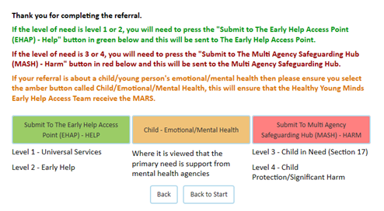
How to refer?
- If you have any urgent concerns that you wish to discuss please contact us on 0161 716 3600
- Through the MARS process which will require the above referral form completing if a mental health need is identified during the process. https://secure.tameside.gov.uk/forms/mars/f1312mars.asp
- The MARS referral form will need to be completed with as much detail as possible to help us offer the appropriate support.

What happens once the referral has been sent?
Your referral will be screened by one of our clinical triage team. Once a decision has been made about which service can best support the needs of the child and their family we will write to you, as the referrer, to let you know the decision. The family will then be contacted by the appropriate service to discuss next steps and offer an appointment. This may be by letter, e-mail or phone.
Contact us
If you have any questions please contact us by phone on 0161 716 3600 or email pcn-tr.hymsearlyhelpaccess@nhs.net
Covid Recovery Plan
Our plans have changed due to Covid. We will be moving forward to a co-located multi-agency Early Help Access Point as soon as we are able. Please note the pathway will not change but contact details are likely to be different in the near future.

