A Parent Guide to using Microsoft Teams for Year 3 - 6
As part of our ongoing work at Gorse Hall to improve our remote learning facility (in case of future local lockdowns or year group isolations), we have set up Microsoft Teams for Years 3-6.
Some of you may be familiar with it because many offices, colleges and secondary schools already use it. It may look complicated at first, but we will only be using a few of its functions and this guide should help you. You will also be able to find this guide on our school website in the Whole School Letters section on the front page.
NB: if you do not have the internet at home, or a laptop or tablet to access Teams, please let the teacher know as soon as possible so they can prepare a physical worksheet for you. (You will still be able to access some of the functions from a smartphone.)
How will we use it?

ALL YEAR: We want to set weekly homework using Teams so that you and your child (and the teachers!) become familiar with using it.

LOCKDOWN/ISOLATIONS: We will post the children’s work and teaching resources (e.g. videos and powerpoints) on Teams for you to access when you/your device is available. We will also send you links to regular video chats so you/your child can keep in touch with the teacher (to support their mental wellbeing and enable them to ask questions about work or worries).

How do I access it?
- Type http://teams.microsoft.com in the address/URL bar or search for ‘microsoft teams login’. (Note: If using an Apple computer, you may need to download the free app, see step 4.)

- You should come to a sign in screen. Type your child’s email address in (attached) and then click ‘Next.’ (It will be something like jbloggs2@gorsehall.tameside.sch.uk)

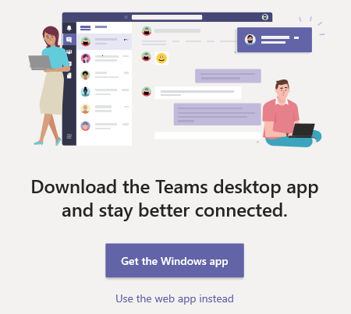
- Type in their individual password (attached). NOTE: your child will also use these details to log on to the school laptops and their class blog so hopefully it won’t take them too long to remember it!

- You should come to this screen. You now have the option of downloading the free app or just using the web version. The main difference is the app allows you receive notifications when the teacher posts something or sets up a video call.

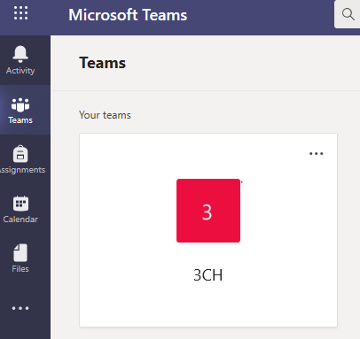
- Once you’ve picked an option (and waited for the app to install if that was your choice), you should hopefully see this screen with your child’s class on…

How do I navigate around Teams?
Once you have clicked on your child’s class, you should see this screen:
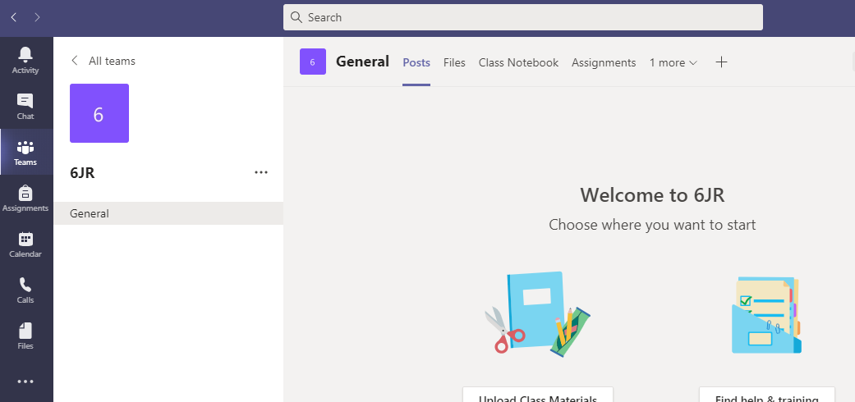
POSTS: this is where the teacher might share whole class messages or reminders.
They will also post teaching videos and video meeting links here if there was a lockdown/isolation.
It is a bit like a Facebook news feed but only the teacher can post on it (for safeguarding).
ASSIGNMENTS:
This is where homework will be posted. Once you click on the assignment, you should be able to read instructions from the teacher, and see when it due in by (see more information on the next page).
ACTIVITY: This is where you will see notifications if the teacher has posted something.
.

CALENDAR: if the teacher arranges a video call (during a lockdown), it will appear in your calendar.

How do I access homework?

Once you have clicked on an ASSIGNMENT, you will see something like this…
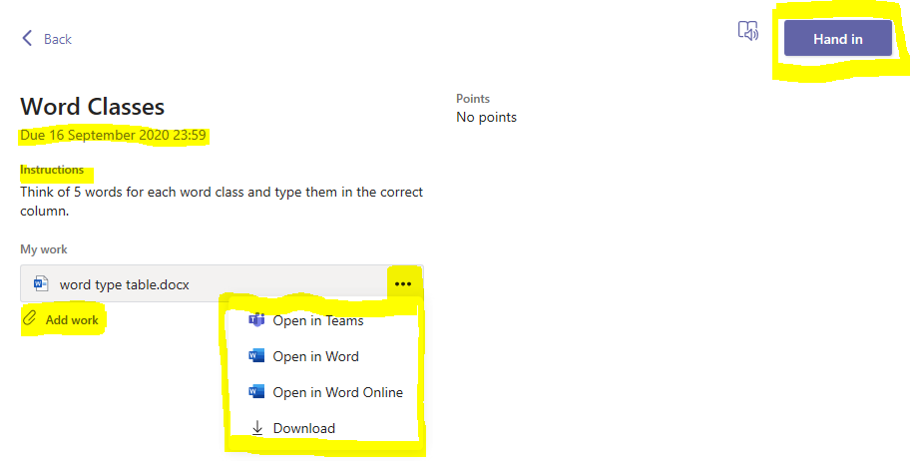
3)Click on the 3 dots to bring up these options. The easiest option is usually to download the homework, complete it and save it to your documents or computer. However, you can try all the options to see which works best for you.
1)Tells you when it is due in by.
2)The teacher may add instructions or even a website to help you complete the homework.
4)When you have finished the homework, this is where you upload it.
5)Click HAND IN once you have uploaded it.
More benefits to Microsoft Teams
You can download Microsoft Office for your child for free!
Search for ‘office 365’ and login using your child’s individual details. It should bring you to this screen:
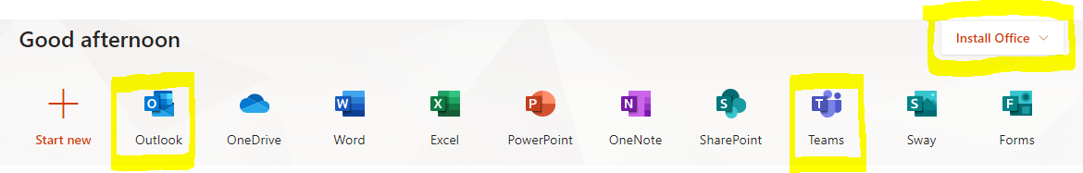OUTLOOK: this is where your child’s email account is, which you could use to email the teacher with if you wish. Please do not allow your child to email anybody without supervision!
TEAMS: this is another way to access Teams
INSTALL OFFICE: simply click on this link to download Office which will allow you to use Word, Powerpoint, Excel and more.

Microsoft Teams works on a range of devices.
You can access it through laptops, tablets and most smart phones. However, you will get the best experience from it from a laptop or desktop computer.

It is also great preparation for your child’s future both at secondary school, and in the world of work. So do persevere with it even if it seems tricky at first! If you need help, please contact school. There are also many help videos and tutorials available online.

